**(1). Meta : Plan a Campaign for a Budget below.   
  
URL:  
  
Task 1:**[**https://docs.google.com/spreadsheets/d/1xAFxDanzQDEg_5DiBnUKAsp0uxmeTH_v/edit?usp=sharing&ouid=105593835773971789057&rtpof=true&sd=true**](https://docs.google.com/spreadsheets/d/1xAFxDanzQDEg_5DiBnUKAsp0uxmeTH_v/edit?usp=sharing&ouid=105593835773971789057&rtpof=true&sd=true) **Task 2:**[**https://docs.google.com/spreadsheets/d/1MqSKQh3inUR4DgeWIa734IeXiAAtdCXY3F1u54TSsOs/edit?usp=sharing**](https://docs.google.com/spreadsheets/d/1MqSKQh3inUR4DgeWIa734IeXiAAtdCXY3F1u54TSsOs/edit?usp=sharing)

**(2) What is the use of Email Marketing?**

Email marketing is a digital marketing strategy used to connect with potential and existing customers via email to promote products, services, or brand awareness. It is a highly effective and cost-efficient tool for businesses to maintain communication with their audience, build relationships, and drive conversions.

**Key uses include:**

* **Customer Engagement:** Keeping customers informed and engaged with newsletters, updates, and offers.
* **Lead Nurturing:** Educating prospects and guiding them through the sales funnel.
* **Product/Service Promotion:** Announcing new products, special deals, or limited-time offers.
* **Personalized Communication:** Delivering tailored content based on user preferences and behaviors.
* **Building Brand Loyalty:** Strengthening customer relationships and encouraging repeat business.
* **Feedback Collection:** Conducting surveys or collecting reviews to improve offerings.

### **(3) What Goals Can You Achieve with the Help of Email Marketing?**

Email marketing can help businesses accomplish several objectives, such as:

1. **Increase Sales and Conversions**Drive purchases with targeted campaigns and offers.  
   Upsell or cross-sell related products or services.
2. **Enhance Customer Retention**Keep customers engaged with regular updates and loyalty programs.
3. **Boost Brand Awareness**Consistently remind your audience of your brand through well-crafted emails.
4. **Generate Leads**Use lead magnets (like free ebooks or discounts) to collect email addresses and build your subscriber base.
5. **Educate the Audience**Share valuable content like tutorials, guides, or industry news to position your brand as an authority.
6. **Improve Website Traffic**Encourage users to visit your website through CTAs (call-to-actions) in your emails.
7. **Drive Event Participation**Promote webinars, live events, or workshops to boost attendance.
8. **Collect Feedback**Use surveys or polls to understand customer satisfaction and gather insights for improvement.

**(4).Set-up an automation email for www.esellerhub.com abandon cart.   
  
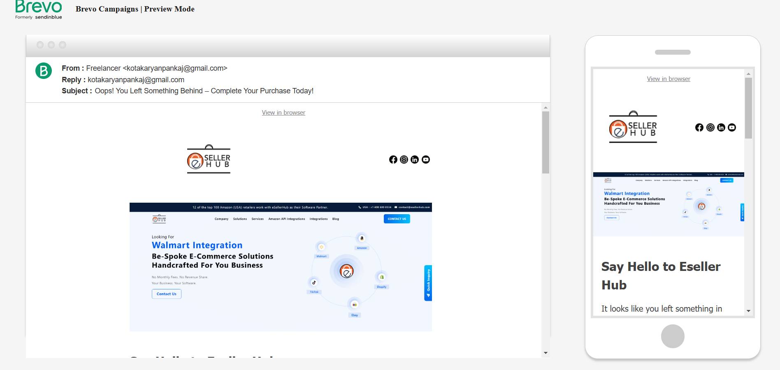  
  
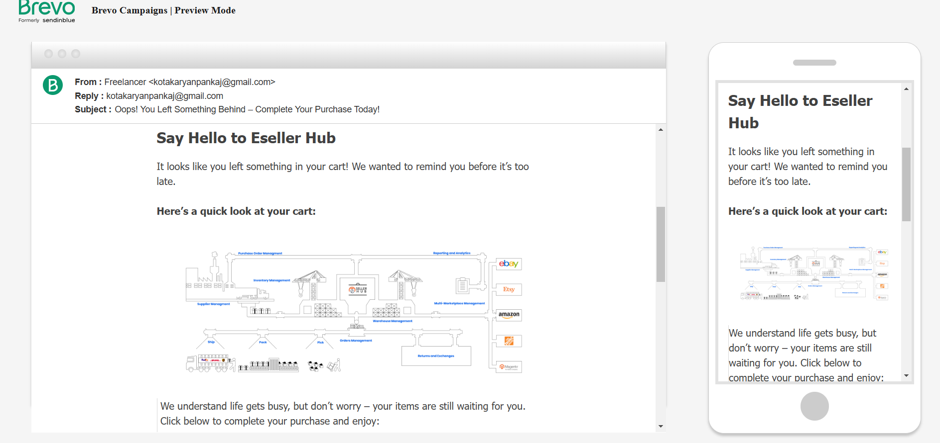  
  
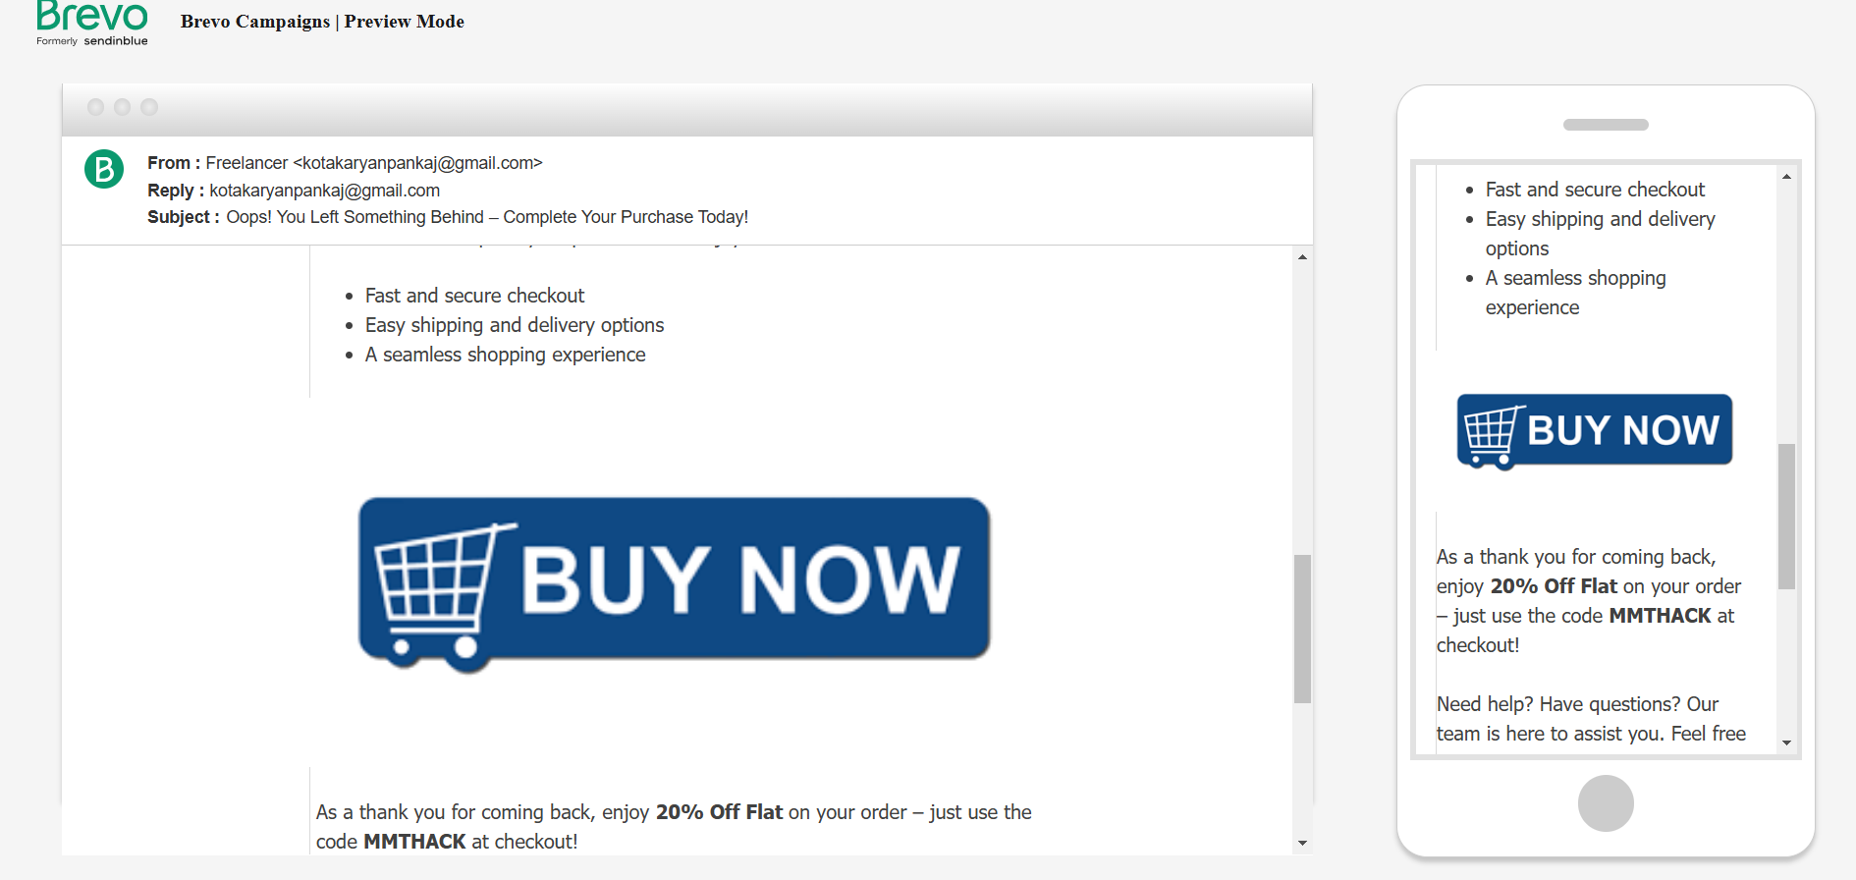  
  
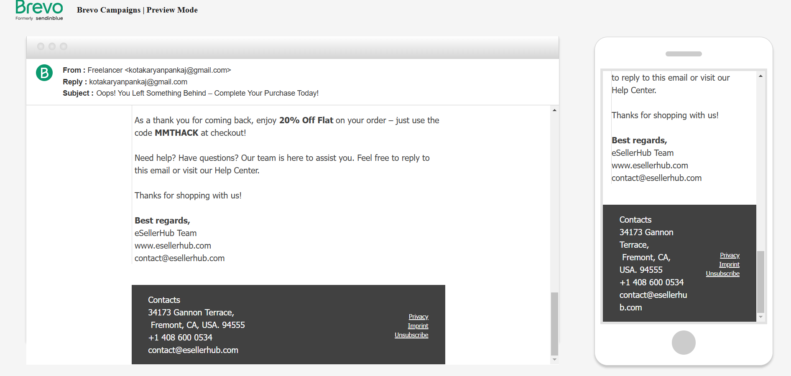  
  
Report Link:** [**https://drive.google.com/file/d/1LZVPba2rd2ITjt1kVa3sTqSV4reJG6z6/view?usp=sharing**](https://drive.google.com/file/d/1LZVPba2rd2ITjt1kVa3sTqSV4reJG6z6/view?usp=sharing) **(5) What is Affiliate Marketing?**

Affiliate marketing is a performance-based marketing strategy where individuals or companies (affiliates) promote a business's products or services in exchange for a commission on the sales or leads they generate. Affiliates use their websites, blogs, social media, or other digital platforms to attract potential customers and drive them to the business's website through unique affiliate links.

**How It Works:**

1. An affiliate joins a company's affiliate program.
2. The affiliate promotes the company's products or services through custom referral links, banners, or other marketing materials.
3. When a user clicks the link and performs a desired action (e.g., makes a purchase or signs up), the affiliate earns a commission.

### **(6) Famous Websites for Affiliate Marketing**

Here are some well-known affiliate marketing platforms and programs:

1. **Amazon Associates –** Offers commissions on a wide range of products available on Amazon.
2. **ClickBank –** Focuses on digital products, including ebooks and courses.
3. **ShareASale –** A marketplace for affiliates to connect with a variety of merchants.
4. **CJ Affiliate (Commission Junction) –** A popular platform with access to top brands and advertisers.
5. **Rakuten Advertising –** Provides access to global brands and retailers.
6. **eBay Partner Network –** Enables affiliates to promote eBay products.
7. **Shopify Affiliate Program –** Focused on promoting Shopify's platform and services.
8. **Bluehost Affiliate Program –** A high-paying affiliate program for promoting web hosting services.

### **(7) Platforms You Can Use for Affiliate Marketing**

Affiliates can use a wide range of platforms to promote products and earn commissions, such as:

1. **Websites/Blogs**Create niche-specific blogs or websites with content that promotes affiliate products.
2. **Social Media Platforms  
   Instagram:** Use posts, stories, and reels to showcase products.  
   **Facebook:** Share affiliate links via pages, groups, or ads.  
   **YouTube:** Create video reviews, tutorials, or unboxings with affiliate links in descriptions.  
   **Pinterest:** Pin content with affiliate links in pins.
3. **Email Marketing**Use email campaigns to share affiliate links and product recommendations with subscribers.
4. **Forums and Communities**Share affiliate links in discussions where relevant (e.g., Reddit, Quora).
5. **Paid Advertising**Use platforms like Google Ads, Facebook Ads, or Instagram Ads to promote affiliate products to a targeted audience.
6. **E-commerce Platforms**Integrate affiliate links on platforms like Shopify or WooCommerce.
7. **Podcasts**Mention affiliate products in episodes and share links in descriptions.
8. **Mobile Apps**Create apps or tools that include affiliate promotions for relevant products.

**(8).Youtube:**[**https://docs.google.com/spreadsheets/d/1zafY_EGDkTect6-iZcE7VEAI66XnxBvJ/edit?usp=sharing&ouid=105593835773971789057&rtpof=true&sd=true**](https://docs.google.com/spreadsheets/d/1zafY_EGDkTect6-iZcE7VEAI66XnxBvJ/edit?usp=sharing&ouid=105593835773971789057&rtpof=true&sd=true)